# Task 1:

Code:

#include <stdio.h>

int main() {

int array[3][3];

for (int row = 0; row < 3; row++) {

for (int col = 0; col < 3; col++) {

printf("Enter score for participant %d, activity %d: ", row+1, col+1);

scanf("%d", &array[row][col]);

}

printf("\n");

}

int sumAct = 0, sumPart = 0;

for (int part = 0; part < 3; part++) {

sumPart = 0;

for (int act = 0; act < 3; act++) {

sumPart += array[part][act];

}

printf("Sum for participant %d: %d", part+1, sumPart);

printf("\n");

}

printf("\n");

for (int act = 0; act < 3; act++) {

sumAct = 0;

for (int part = 0; part < 3; part++) {

sumAct += array[part][act];

}

printf("Sum for activity %d: %d", act+1, sumAct);

printf("\n");

}

return 0;

}

Screenshots:

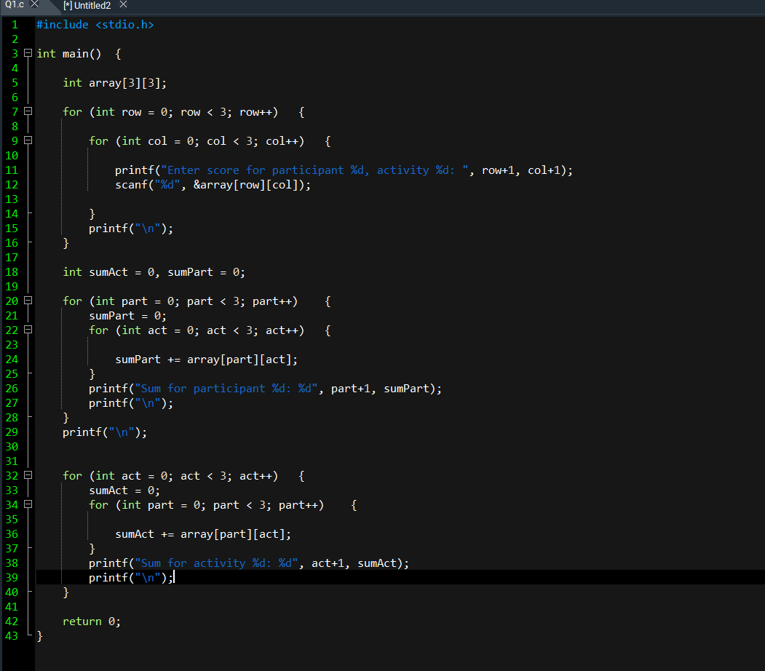

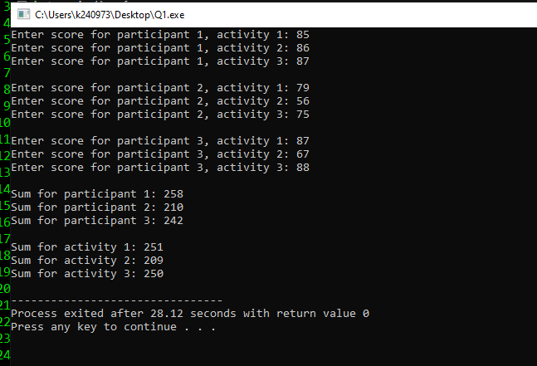

# Task 2:

Code: #include <stdio.h>

int main() {

int array[4][4];

for (int student = 0; student < 4; student++) {

for (int subject = 0; subject < 4; subject++) {

printf("Enter grade for student %d, subject %d: ", student+1, subject+1);

scanf("%d", &array[student][subject]);

}

printf("\n");

}

for (int student = 0; student < 4; student++) {

for (int subject = 0; subject < 4; subject++) {

if (array[student][subject] < 0) {

array[student][subject] = 0;

}

}

}

for (int student = 0; student < 4; student++) {

for (int subject = 0; subject < 4; subject++) {

printf("%d ", array[student][subject]);

}

printf("\n");

}

return 0;

}

Screenshots: 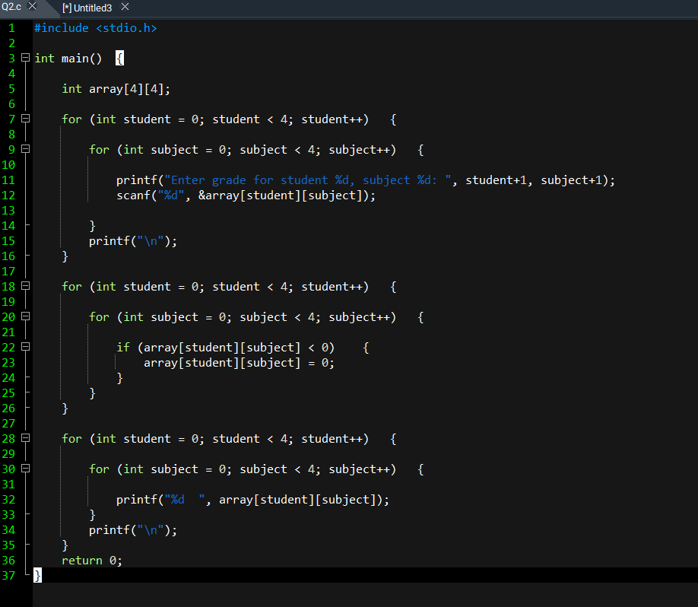

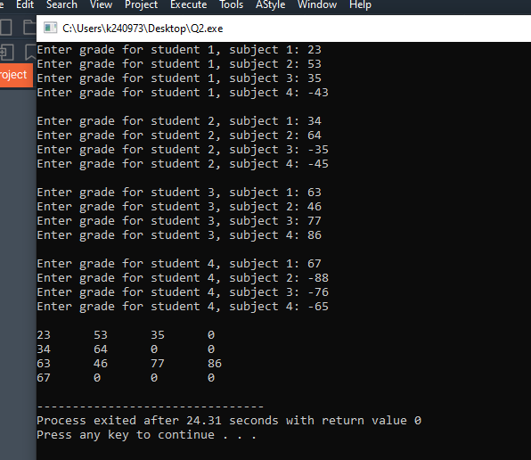

# Task 3:

Code:

#include <stdio.h>

int main() {

int num;

printf("Enter n: ");

scanf("%d", &num);

int value = num;

int iter = 0;

while (value > 0) {

for (int i = 0; i < iter; i++) printf(" ");

for (int j = value; j > 0; j--) {

printf("%d ", j);

}

iter+=1;

value -= 1;

printf("\n");

}

value += 2;

iter-=2;

while (value <= num) {

for (int i = 0; i < iter; i++) printf(" ");

for (int j = value; j > 0; j--) {

printf("%d ", j);

}

value++;

iter--;

printf("\n");

}

return 0;

}

Screenshots:

